Registration Form for  LEAN SPRING SUMMIT | - 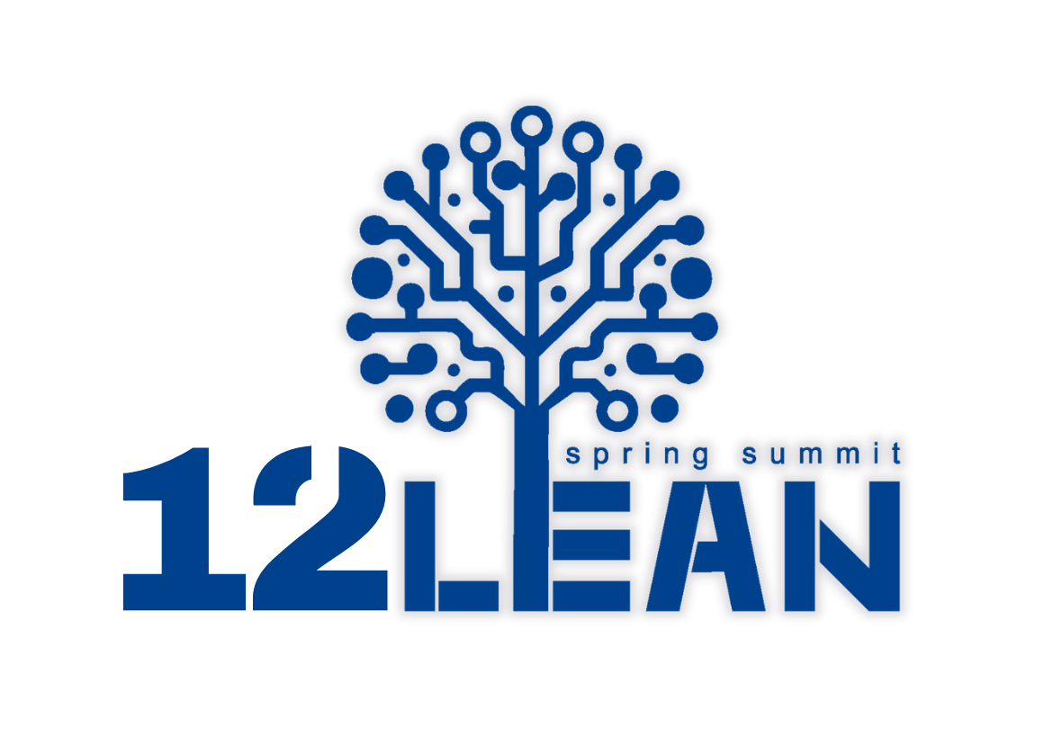  - 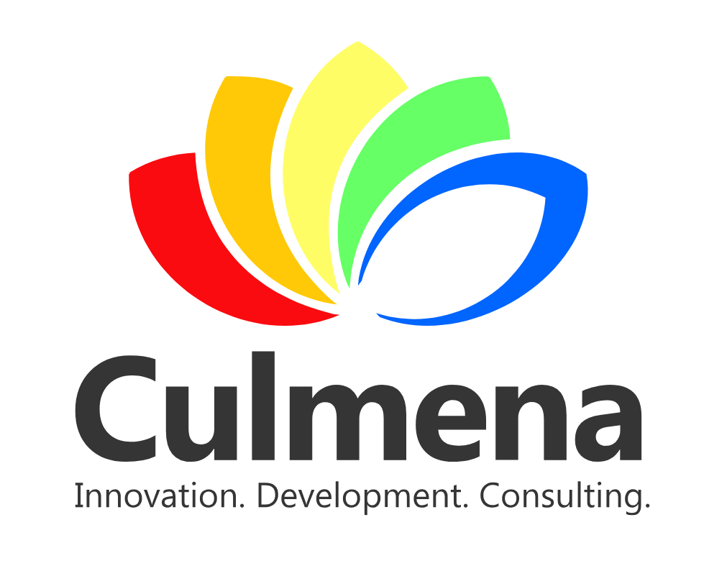
No. | Full name | E-mail | Phone number
1. | [Enter data] | [Enter data] | [Enter data]
2. | [Enter data] | [Enter data] | [Enter data]
3. | [Enter data] | [Enter data] | [Enter data]
4. | [Enter data] | [Enter data] | [Enter data]
5. | [Enter data] | [Enter data] | [Enter data]

Company/Organization name: | [Enter data]
Adress: | [Enter data]
VAT ID: | [Enter data]

Conference information:
Program | Wednesday, May 20, 2026 | Thursday, May 21, 2026
Participation Fee | Super Early bird Discount (payments until April 15, 2026) | 280,00 + VAT
Participation Fee | Early bird Discount  (payments until May 11, 2026) | 320,00 + VAT
Participation Fee | Group Discount  (3-5 participants from the same company, per person) | 260,00 EUR + VAT
Participation Fee | Group Discount (6+ participants from the same company, per person) | 199,00 EUR + VAT
Participation Fee | Regular Registration Fee | 500,00 EUR + VAT
Includes | Conference materials, coffee break, lunch
Venue | Hotel Rijeka Costabella Beach Resort & Spa
Accomodation | Price per night, including breakfast and dinner (multiple nights available):
Accomodation | Single room | 332,00 EUR per night
Accomodation | Double room | 429,00 EUR per night (214,50 per person)
Includes | Breakfast and dinner
* Please make your application for accommodation by April 20, 2026 because the preferential price for accommodation for LSS conference participants is valid until the specified date.

Applications and information:  Submit your completed registraton form via email:  Phone: +385 99 603 2288  E-mail: nela.biondic@culmena.hr  E-mail: info@culmena.hr  Payment Details:  Recipient:  Culmena d.o.o., Maksimirska 115, Zagreb  VAT ID: 72205564976  Payment reference:  Registration Fee, [Company name] – LSS 2026  Bank: Zagrebačka banka, IBAN: HR3223600001101782054 | Accomodation Payment Details:  Upon registration, you will receive detailed instructions on booking accommodation at preferential rates for LSS participants.  For additional inquiries, please contact: :  costabella.reservations@hilton.com  Phone: +385 51 600 17

Cancellation Policy
- Full refund if canceled up to 30 days before the conference
- 50% refund if canceled 29 to 14 days before the conference
- No refund if canceled less than 13 days before the conference

